

1
2
3
4
5

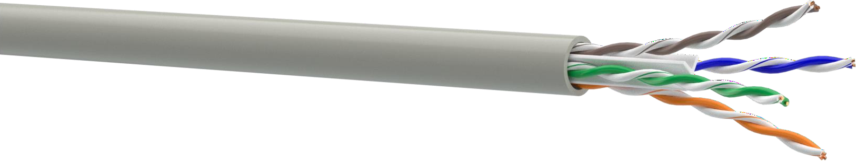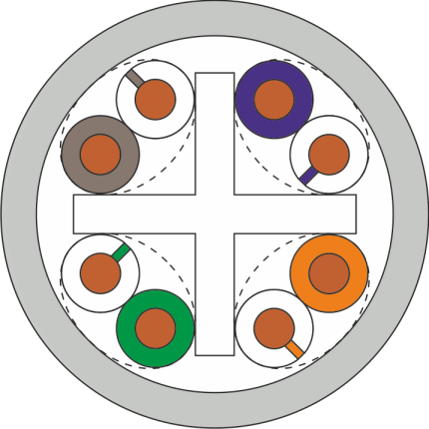APPLICATION

DESIGN
- Conductor: soft copper wire Ø 0,54 mm
- Insulation: HDPE, Ø 1,02 mm
- Pair: two conductors twisted together Color identification of pairs:
pair 1: white-blue / blue
pair 2: white-orange / orange pair 3: white-green / green pair 4: white-brown / brown
- Cross-web 2,6x2,6 mm
- Jacket: LSZH, sheath thickness 0,5 mm,
nominal cable Ø 6,1 mm, color RAL 7035
PBX, V.11, X.21, ISDN, Ethernet (10Base-T), ATM-25/52/155 Mbit/s,
100VG-AnyLAN, Fast Ethernet (100BASE-TX), Token Ring 16/100 Mbit/s, Gigabit Ethernet (1000BASE-T, 1000BASE-TX), Firewire 100 Mbit/s

CATEGORY 6 250MHZ U/UTP 4PR LSZH

INSTALLATION AND OPERATION CONDITIONS
For stationary installation inside buildings, stations, structures and equipment. Operated on frequencies up to 250 MHz.

СOMPLIANCE WITH THE REQUIREMENTS
Cable: IEC 61156-5
System: ISO/IEC 11801-1, EN 50173-1, ANSI/TIA-568-C.2
Fire safety: IEC 60332-1, IEC 60332-3, IEC 61034-1,
IEC 60754-2
CPR rating: Eca

MECHANICAL CHARACTERISTICS
Temperature range:
During installation -10 °C ... +60 °C
After installation -20 °C ... +60 °C
Bending radius:
During installation ≥ 8 cable diameters After installation ≥ 4 cable diameters
Tensile stress ≤ 85 N

ELECTRICAL CHARACTERISTICS AT 20 °C
 | Unit | Value
Capacitance | pF/m | ≤ 56
Direct current resistance | Оhm/km | ≤ 85
Insulation resistance | GOhm/km | ≥ 5
Resistance unbalance | % | 2
Signal propagation velocity | s | 0,70
Propagation delay | ns/100 m | ≤ 534+36/√f
Delay shift on the frequency 100 MHz | ns/100 m | ≤ 30
Characteristic impedance in the frequency range of: 1-100 MHz  100-250 MHz | Ohm | 100±15  100±22
Test voltage between cores, (DC, 2 s) | kV | 2,5

Frequency, MHz | 1 | 4 | 10 | 16 | 20 | 31,25 | 62,5 | 100 | 250
Attenuation, dB, max | 2,1 | 3,8 | 6 | 7,6 | 8,5 | 10,8 | 15,5 | 19,9 | 33
NEXT, dB, min | 75,3 | 66,3 | 60,3 | 57,3 | 55,8 | 52,8 | 48,3 | 45,3 | 39,3
PS NEXT, dB, min | 72,3 | 63,3 | 57,3 | 54,3 | 52,8 | 49,8 | 45,3 | 42,3 | 36,3
ELFEXT, dB, min | 68 | 56 | 48 | 44 | 42 | 38 | 32 | 28 | 20
PS ELFEXT, dB, min | 65 | 53 | 45 | 41 | 39 | 35 | 29 | 25 | 17
RL, dB, min | 20,0 | 23,0 | 25,0 | 25,0 | 25,0 | 23,6 | 21,5 | 20,1 | 17,3
IEC 61156-5, values lower than 4 MHz are given for information only

ORDER INFORMATION
P/N | Cable name | Standard packing | Weight, kg/km
49213 | KPVong-HF-VP (250) 4x2x0,54 (U/UTP-cat.6 LSOH) | box, 305 m | 38,3

